CITY OF CARMEL

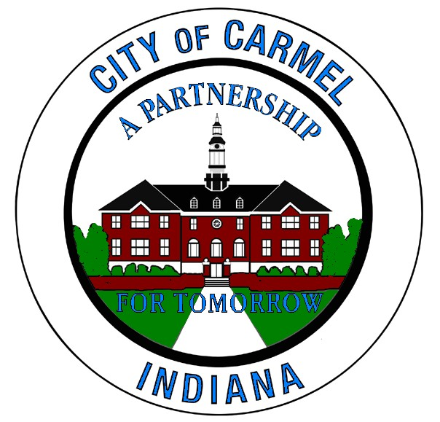

PROJECT MANUAL

106th Street over Keystone Parkway Bridge Beam Replacement and Various Repairs

Project No. 16-ENG-01

HAMILTON COUNTY, INDIANA

City of Carmel Engineering Department
One Civic Square
Carmel, Indiana 46032
Office: (317) 571-2441

March 2016

